DVR 420 | 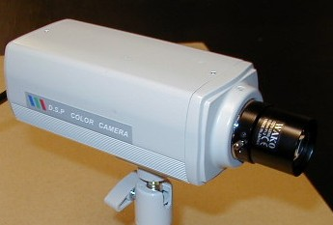1/3" Color Low Lux CCD Camera
Item | Describe
Sensor Chip Brand | SONY
Picture Element | PAL:500(H)x582(V)
Scanning Frequency | CCIR/PAL:15625Hz(H),50Hz(V)
H. Resolution | More than 420 TV Lines
Illumination | 0.3 Lux (F1.2)
Synchronizing | Internal Sync., 2:1 Interlace
Auto White Balance | AUTO
Auto Gain Control | AUTO
S/N Ratio | More than 48 dB
Gamma Correction | 0.45
Auto Shutter | AUTO[1/60(50)~1/100,000]
Video Output | 1.0Vp-P75ohm
Lens Mount | CS/C Mount
Backlight Compensation | ON/OFF Switchable
Power | DC12V / 150mA ; AC90-264V / 3.5W(Switching Powe)
Dimension / Weight | 125(D)x55(W)x47(H)mm / DC:250g AC:420g
Operating Temperature | -10°C ~ +50°C

