DVR 470 | 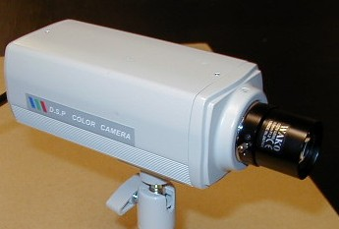1/3" Color Low Lux CCD Camera
Item | Describe
Sensor Chip Brand | SONY
Picture Element | PAL:537(H)x597(V)
Scanning Frequency | PAL:15625Hz(H),50Hz(V)
H. Resolution | 470 TV Lines
Illumination | 0.3 Lux (F1.2) 5600¢XK
Synchronizing | Internal Sync., 2:1 Interlace
Auto White Balance | ATW/AWC switchable(Zero color rolling) range:3200-10000K
Auto Gain Control | ON/OFF Switchable
S/N Ratio | 52dB(Min.)/60dB(TYP)(AGC OFF)
Gamma Correction | 0.45
Auto Shutter | AUTO,ON/OFF Switchable[1/60(50)~1/100,000)
Video Output | 1.0Vp-P75ohm
Lens Mount | CS/C Mount
Backlight Compensation | AUTO
Power | DC 12V / 150mA
Dimension / Weight | 116(D)x50.5(W)x64.5(H)mm / 280g
Operating Temperature | -10°C ~ +50°C

