DVR B420 | 1/4" Color CCD Camera
Item | 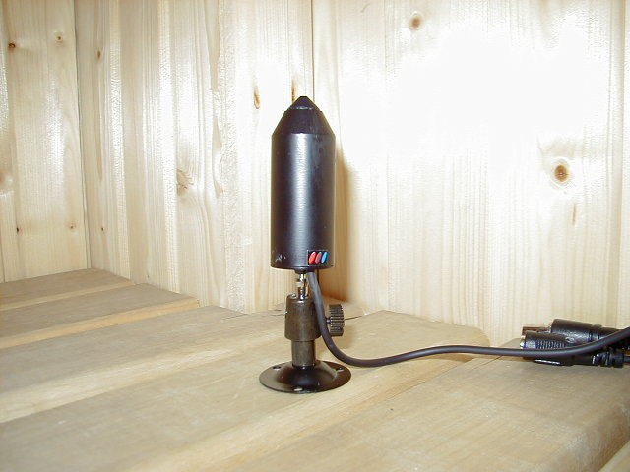
Sensor Chip Brand | Sharp
Picture Element | PAL:500(H)x582(V)
Scanning Frequency | CCIR/PAL:15625Hz(H),50Hz(V)
H. Resolution | More than 420 TV Lines
Illumination | 1 Lux F 2.0
Synchronizing | Internal Sync., 2:1 Interlace
Auto White Balance | AUTO
Auto Gain Control | AUTO
S/N Ratio | More than 48 dB
Gamma Correction | 0.45
Auto Shutter | AUTO[1/60(50)~1/100,000]
Video Output | 1.0Vp-P75ohm
Lens Mount | 3,6 mm lens
Backlight Compensation | AUTO
Power | DC 12V / 130mA
Dimension / Weight | 22dia x76mm / 80g
Operating Temperature | -10°C ~ +45°C

