DVR IR 10 | 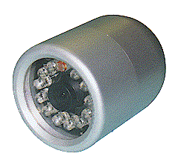1/4" Color IR Camera
Item | Describe
Sensor Chip Brand | SONY
Picture Element | PAL:500(H)x582(V)
Scanning Frequency | CCIR/PAL:15625Hz(H),50Hz(V)
H. Resolution | More than 400 TV Lines
Illumination | 0 Lux (IR ON)
Infrared Ray LED | 12 pcs
Infrared Ray Distance | 10 Meters
Water Resistance | IP68
Synchronizing | Internal Sync., 2:1 Interlace
Auto White Balance | AUTO
Auto Gain Control | AUTO
S/N Ratio | More than 48 dB
Gamma Correction | 0.45
Auto Shutter | AUTO[1/60(50)~1/100,000]
Video Output | 1.0Vp-P75ohm
Lens Mount | 4.3 mm Board lens
Backlight Compensation | AUTO
Power | DC 12V / 280mA
Dimension / Weight | 53diax85(D)mm / 270g
Operating Temperature | -10°C ~ +45°C

