DVR IR 50 | 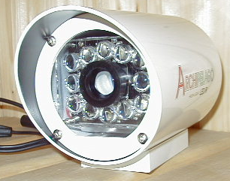1/3" Color IR Camera
Item | Describe
Sensor Chip Brand | SONY
Picture Element | PAL:500(H)x582(V)
Scanning Frequency | CCIR/PAL:15625Hz(H),50Hz(V)
H. Resolution | 380 TV Lines
Illumination | 0 Lux (IR ON) ; Color Auto Change to Pure BW In Low Lux Status
Infrared Ray LED | 12 pcs High light LED with condensing lens
Infrared Ray Distance | 50 Meters
Water Resistance | IP66 Housing
Synchronizing | Internal Sync., 2:1 Interlace ; Auto Line Lock Function
Auto White Balance | AUTO
Auto Gain Control | AUTO
S/N Ratio | More than 48 dB
Gamma Correction | 0.45
Auto Shutter | AUTO[1/60(50)~1/100,000]
Video Output | 1.0Vp-P75ohm
Lens Mount | 25mm
Backlight Compensation | AUTO
Power | 12V DC
Dimension / Weight | 95 dia 150 mm long / 950g
Operating Temperature | -20°C ~ +50°C

