DVR PT 380
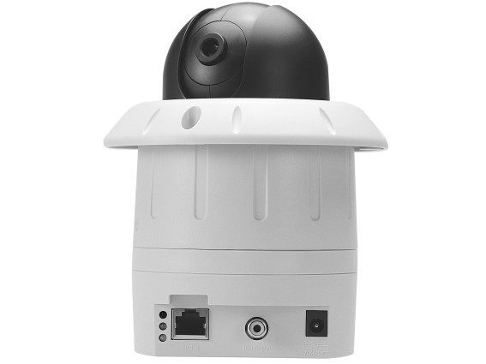
IP Addressable Speed Dome Camera
Features & Functions
1.The world's lightest & smallest IP Addressable Speed Dome Camera.
2.All functions can be set and controlled via Internet.
3.Easy control interface, surveillance & play by using Internet Explorer.
4.Easy system maintains, setting-up & linking.
5.Horizontal pan 360°, vertical tilt 90°.
6.Using control bottoms to move camera, or choose viewing between preset points.
7.Presets at 20 points.
8.Moving speed: Level 1 ~ 8 preset-able, moving speed between presets at 240°/second.
9.Auto-cruise available.
10.Color CCD with quality & sharp images.
SPECS
1.Moving ranges: Pan 360°, tilt 90°.
2.Moving Speed: Level 1 ~ 8 preset-able, moving between presets 240°/second.
3.Preset: 20 points, program-able.
4.Camera resolutions: 380 TV lines.
5.CCD Sensor: 250 K pixels, 1/3" color CCD.
6.Light Sensitivity: 1.0 Lux.
7.Focal Length: f6mm
8.Aperture: F 2.0
9.Protocal: SMTP, FTP, DHCP, ARP, TCP/IP, UDP
10.Video Format: JPEG / M-JPEG Compression
11.Resolution Option: 176 X 144, 320 X 240, 352 X 288, 640 X 480
12.Frame Rate: 30 fps
13.Operating System: Microsoft Windows
14.Browser: Internet Explorer 5.X or above
15.Administration: User level password protection
16.Analog Video Output: 1 port
17.Image controls: Brightness, Contrast, Saturation, Hue
18.Power Consumption: Operating voltage DC 12 V at 1.5 A
19.Dimention: 100 mm (4 inches) wide / 160 mm (6.5 inches) high
20.Weight: 500 mg

