DVR Fastlins | 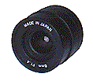Auto Iris Lens (Manual Focus)
Item | 2,8mm 4mm 6mm 8mm 12mm 16mm
Image Format | 1/3" 1/3" 1/3" 1/3" 1/3" 1/3"
Focal Length (mm) | 2.8 4 6 8 12 16
Aperture(F) | 1.4 2,0 1,8 2,0 2,0 2,0
Angle of View(°) | 93.6 80 60 52 25 20

