DVR VL1 | 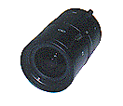Vari-Focus Manual Iris Lens
Item | Describe
Image Format | 1/3"
Focal Length (mm) | 3.5~8
Aperture(F) | 1.4
Angle of View(°) | 43,2~96,1

DVR VL2 | 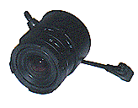Vari-Focus Auto Iris Lens
Item | Describe
Image Format | 1/3"
Focal Length (mm) | 3,5~8
Aperture(F) | 1.4
Angle of View(°) | 43,2~96,1

DVR VL3 | Vari-Focus Auto Iris Lens
Item | Describe
Image Format | 1/3"
Focal Length (mm) | 2,8~12
Aperture(F) | 1.4 - 360
Angle of View(°) | 25-103

DVR VL4 | Vari-Focus Auto Iris Lens
Item | Describe
Image Format | 1/3"
Focal Length (mm) | 6~15
Aperture(F) | 1.4 - 360
Angle of View(°) | 23~54

DVR VL5 | Vari-Focus Auto Iris Lens
Item | Describe
Image Format | 1/3"
Focal Length (mm) | 6~60
Aperture(F) | 1.4 - C
Angle of View(°) | 6~50

