DVR H1 | 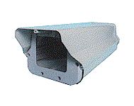Camera Housing
Item | Describe
Construction | + Heater & Blower
Dimension | 142(W)x390(D)x115(H)mm
Weight | 1.4 kgs

DVR H2 | Camera Housing
Item | Describe
Construction | Aluminium
Dimension | 142(W)x390(D)x115(H)mm
Weight | 1.2 kgs

