Model | EU-130B
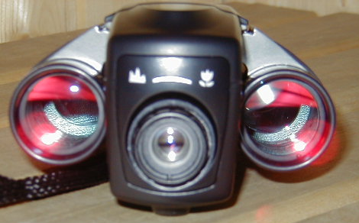
Binocular
Specification |  | 8 x 21 mm
Angle of view |  | 7.3¢X
Field of View At 1000m |  | 131m
Exit pupil |  | 2.6mm
Focusing Range |  | 5m ~ ¡Û
Digital Camera
Resolution |  | 1280 x 1024 pixels
Number of Pictures |  | HI : 18(SXGA) / LOW : 70(VGA)
Image sensor |  | CMOS Sensor
Focus Length |  | 34.77mm
F Value |  | 4.5
Focus Range |  | 3 Meter to lnfinity
Angle of View |  | 13.9¢X
Video Frame Rate |  | 30fps(CIF) / 20fps(VGA)
Interface |  | USB(TWAIN)
Self-timer |  | 10 Seconds
Erase |  | Manual(once/all)
Exposure |  | Auto
Memory |  | 8MB SDRAM
Auto Power off |  | 3 min.
2-Way Shooting |  | Yes
Video Recorder |  | Yes
TN-LCD Display |  | Yes
PC Camera |  | Yes
PC Os |  | Window 98 /SE / ME / 2000 / XP
Power Source |  | 2 x AAA Tyte Alkaline Batteries / USB

