DVR Rök 420 | 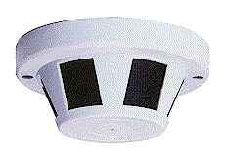1/4" Color Dome
Item | Describe
Sensor Chip Brand | SONY, Sharp eller Panasonic
Picture Element | CCIR:500(H)x582(V)
Scanning Frequency | CCIR/PAL:15625Hz(H),50Hz(V)
H. Resolution | 420 TV Lines
Illumination | 0.4 Lux (F1.2)
Synchronizing | Internal Sync., 2:1 Interlace
Auto White Balance | AUTO
Auto Gain Control | AUTO
S/N Ratio | More than 48 dB
Gamma Correction | 0.45
Auto Shutter | AUTO[1/60(50)~1/100,000]
Video Output | 1.0Vp-P75ohm
Lens Mount | 3.6 mm Board lens (4,6,8,12 mm Optional)
Backlight Compensation | AUTO
Power | DC 12V / 125mA
Dimension / Weight | 125øx52(H)mm / 190g
Operating Temperature | -10°C ~ +45°C
