Product : | DVR S4, 2.4 GHz Wireless pen camera. Sender 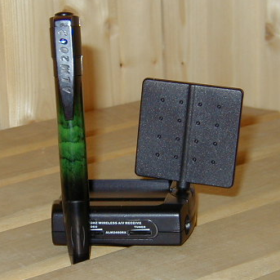
Approvals :
Specification :
  Camera. Transmitter:
  1 Channel in frequency | : 2412, 2452, 2432, & 2472 MHz
  Range (outdoor) approx. | : 150 meters in L-O-S
  Power supply | : DC 6 - 9V, 75mA
  Audio | : built in mic
  Dimension | : 22,5 x26,54 x 18 mm, 35g
  Operation temperature | : -10 deg.C…+ 55 deg.C
  Min Illimunation | 3 lux @ F1:2
  Lens | 5,6mm 64°
  Automatic exposure, Gain and | White balance
  A/V RECEIVER:
  4 Channels in frequencies | : 2412, 2452, 2432, & 2472 MHz
  Video output | : 1 Vp-p/75 Ohm
  Audio output | : 0.8V / 600 Ohm
  Audio bandwidth | : 50- 17000 Hz
  Power supply | : DC12V, 200mA
  Antenna | : Directional antenna
  Dimension | : 100 x 88 x 40mm
  Weight | : 150 grams
  Operation temperature | : -10 deg.C…+ 55 deg.C

